**At useR!2019 in Toulouse, ThinkR opened a quizz allowing to win a *pipe knight*. About a hundred of respondents won this Playmobil. In this blog post, we review the questions and respondents answers. We’ll see that the crowd as almost always right, but they do not know who the real R oracle is…**

The quizz showed some difficulties and tricks of the base R language. This does not reflect your capacity to be a good R-programmer at all. This is only a game with tricky code that you surely do not want to write this way, but which is allowed by R. If you have ever been confronted to unattended behaviour with NULL values, some questions may speak to you (Isn’t that right, Colin?). Personnally, even after having read the answers twice, I am not sure I can have 100% good…



To win a *pipe knight* people were required to score above 75% on wednesday, and above 60% on thursday and friday. We reduced the limit as respondents seemed to like the challenge of responding without opening an R session. Good attitude !



Let’s explore these answers…

**Libraries**

library(readr)

library(dplyr)

library(tidyr)

library(ggplot2)

library(stringr)

library(grid)

library(gridExtra)

**Clean questions and link with choices**

The dataset is not really tidy. We have to extract questions and choices first, and then respondent answers separately.



List choices with the associated question and identify the correct answers.

# Read dataset

questions <- read_delim("QuizResponses_and_13.csv", delim = ",", n_max = 1, col_names = TRUE)

# Link choices to questions

question_choice <- gather(questions, "question", "choice") %>%

mutate(question = if_else(grepl("^X\\d", question), NA_character_, question)) %>%

fill(question) %>%

mutate(question_id = str_extract(question, "(?<=^Q)(\\d+)(?=:)") %>% as.numeric()) %>%

filter(choice != "Points") %>%

mutate(correct = grepl("✓", choice))

question_choice

## # A tibble: 87 x 4

## question choice question_id correct

##

## 1 Q2: Which proposition(s) return(s… ✕ round(0.5) == … 2 FALSE

## 2 Q2: Which proposition(s) return(s… ✓ round(0.5) == … 2 TRUE

## 3 Q2: Which proposition(s) return(s… ✕ round(0.5) == … 2 FALSE

## 4 Q2: Which proposition(s) return(s… ✕ round(0.5) == … 2 FALSE

## 5 "Q3: What happens if:  dplyr <- \… ✕ Nothing 3 FALSE

## 6 "Q3: What happens if:  dplyr <- \… ✓ it loads dplyr 3 TRUE

## 7 "Q3: What happens if:  dplyr <- \… ✕ it loads data.… 3 FALSE

## 8 "Q3: What happens if:  dplyr <- \… ✕ it returns an … 3 FALSE

## 9 "Q3: What happens if:  dplyr <- \… ✕ it loads both … 3 FALSE

## 10 Q4: What is the name of the Think… ✓ golem 4 TRUE

## # … with 77 more rows

**Read respondents answers**

Let’s tidy the respondent answers dataset and join it with the table of questions and choices.

dataset <- read_delim("QuizResponses_and_13.csv", skip = 1, delim = ",")

all_answers <- dataset %>%

gather("choice", "answer", -X1) %>%

rename(ID = X1) %>%

left_join(question_choice, by = "choice") %>%

arrange(question_id, choice)

all_answers

## # A tibble: 28,000 x 6

## ID choice answer question question_id correct

##

## 1 1.09e10 ✓ round(0.5) ==… Q2: Which proposi… 2 TRUE

## 2 1.09e10 ✓ round(0.5) ==… Q2: Which proposi… 2 TRUE

## 3 1.09e10 ✓ round(0.5) ==… Q2: Which proposi… 2 TRUE

## 4 1.09e10 ✓ round(0.5) ==… Q2: Which proposi… 2 TRUE

## 5 1.09e10 ✓ round(0.5) ==… Q2: Which proposi… 2 TRUE

## 6 1.09e10 ✓ round(0.5) ==… Q2: Which proposi… 2 TRUE

## 7 1.09e10 ✓ round(0.5) ==… Q2: Which proposi… 2 TRUE

## 8 1.09e10 ✓ round(0.5) ==… 1 Q2: Which proposi… 2 TRUE

## 9 1.09e10 ✓ round(0.5) ==… 1 Q2: Which proposi… 2 TRUE

## 10 1.09e10 ✓ round(0.5) ==… Q2: Which proposi… 2 TRUE

## # … with 27,990 more rows

**Overview of answers**

total_correct <- sum(question_choice$correct)

pc_correct <- all_answers %>%

group_by(ID) %>%

summarise(points = sum(as.numeric(answer), na.rm = TRUE)) %>%

mutate(pc = 100 * points/total_correct) %>%

arrange(desc(pc))

Total number of respondents: 250.  
Median percentage of correct answers: 54.  
Number of participants with 100% correct answers: 3.

ggplot(pc_correct) +

geom_histogram(aes(pc), binwidth = 1, colour = thinkridentity::thinkr_cols("dark"), fill = thinkridentity::thinkr_cols("primary")) +

theme_classic() +

scale_x_continuous(limits = c(0, NA)) +

labs(x = "% correct", y = "Number of respondents",

title = "Distribution of percentage of correct answers")

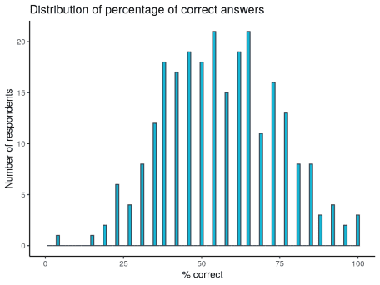

**Create function to build graph for each question**

For each question, we will show the repartition of responses, ordered from most answered. The bar of the correct answers will be filled in green. There are also identified by a ✓ in the choices list.

#' Get question

#'

#' @param q_id id of the question

#'

#' @examples

#' get_question(2)

get_question <- function(q_id) {

question_choice %>%

filter(question_id == q_id) %>%

pull(question) %>%

unique()

}

#' Plot answers of a specific question

#'

#' @param q_id id of the question

#'

#' @examples

#' plot_question(2)

plot_question <- function(q_id) {

title <- get_question(q_id)

answers_id <- all_answers %>%

filter(question_id == q_id)

n_respondents <- length(unique(answers_id$ID))

p <- answers_id %>%

group_by(correct, choice) %>%

summarise(nombre = sum(!is.na(answer))) %>%

mutate(pc = 100 * nombre / n_respondents) %>%

ggplot(aes(reorder(choice, pc), pc, fill = correct)) +

geom_col() +

coord_flip() +

scale_fill_manual(values = c("TRUE" = "green4", "FALSE" = "grey"),

guide = FALSE) +

theme_classic() +

labs(y = "% choosen answer", x = NULL, title = NULL)

title.grob <- textGrob(

label = title,

x = unit(0, "lines"),

y = unit(0, "lines"),

hjust = 0, vjust = 0,

gp = gpar(fontsize = 13)

)

p1 <- arrangeGrob(p, top = title.grob)

grid.arrange(p1)

}

**Explore all answers**

I could have write a loop for all figures, but I wanted to add some comments for some specific questions. So, here we go !  
*Question 1 was the email of respondents. This question is not part of the dataset.*

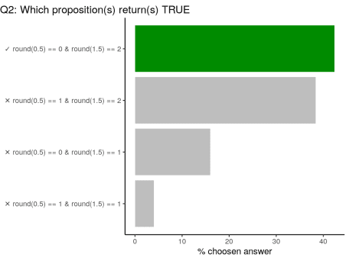

?round Details: Note that for rounding off a 5, the IEC 60559 standard (see also ‘IEEE 754’) is expected to be used, ‘go to the even digit’. Therefore round(0.5) is 0 and round(-1.5) is -2. However, this is dependent on OS services and on representation error (since e.g. 0.15 is not represented exactly, the rounding rule applies to the represented number and not to the printed number, and so round(0.15, 1) could be either 0.1 or 0.2).

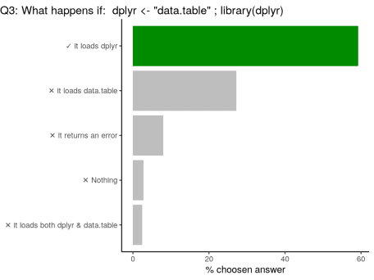

**Code of the question**

dplyr <- "data.table"

library(dplyr)

library is a *r-base* function doing non-standard evaluation (NSE). In the code above, library does not evaluate the R object named dplyr, but uses the symbol. Note that you can load {data.table} with library("data.table") for standard evaluation or use library(dplyr, character.only = TRUE) in this case. Who said “confusing”?

library(dplyr, character.only = TRUE)

## data.table 1.12.2 using 2 threads (see ?getDTthreads). Latest news: r-datatable.com

##

## Attaching package: 'data.table'

## The following objects are masked from 'package:dplyr':

##

## between, first, last

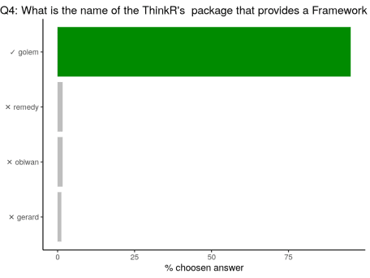

Question was: Q4: What is the name of the ThinkR’s  package that provides a Framework for building robust shiny apps ?

.

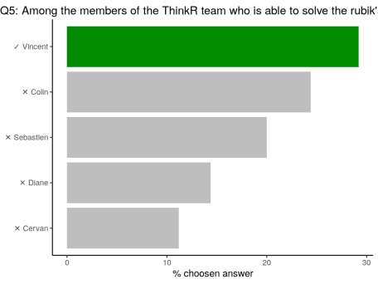

Q5: Among the members of the ThinkR team who is able to solve the rubik’s cube the fastest ?

Vincent owns dozens of Rubik’s cube at home. He trains every day! He beats us all…

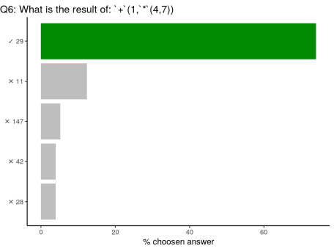

+ and * are R functions. You can call them using ` to be used with parenthesis like any other R function. It is also a way to call help on this function: ?`+`.

# Hence:

`+`(1, `*`(4, 7)) == (1 + (4 * 7))

## [1] TRUE

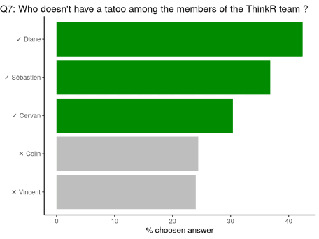

The question was: Who does **not** have a tatoo? Colin tatoo’s are noticable. Vincent has one tatoo on the chest All other ThinkR members do not have any tatoo (for now…?).

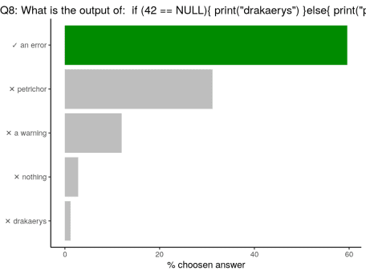

**Code of the question**

if (42 == NULL) {

print("drakaerys")

} else {

print("petrichor")

}

#> Error in if (42 == NULL) { : l'argument est de longueur nulle

In the if statement, the output should be of length 1. Testing a value against NULL returns an object of length 0.

# Test against NULL

(42 == NULL)

## logical(0)

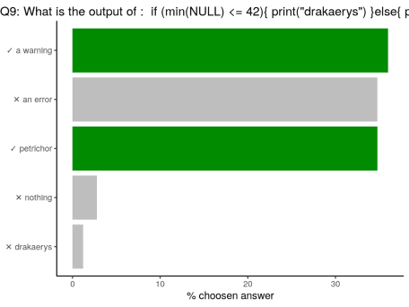

**Code of the question**

if (min(NULL) <= 42) {

print("drakaerys")

} else {

print("petrichor")

}

## Warning in min(NULL): aucun argument trouvé pour min ; Inf est renvoyé

## [1] "petrichor"

As said above, in the if statement, the output should be of length 1. Contrary to the above question, min(NULL) is of length 1 as it returns Inf, with a *warning*. Hence Inf is not lower than 42, and the test returns petrichor. Yes, R behaviour with NULL is tricky…

min(NULL)

## [1] Inf

(min(NULL) <= 42)

## [1] FALSE

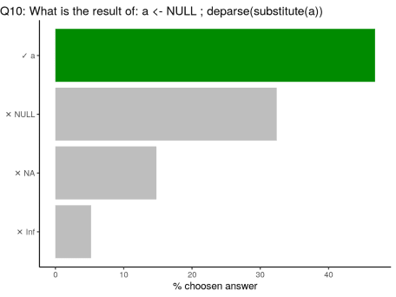

**Code of the question**

a <- NULL

deparse(substitute(a))

## [1] "NULL"

All is about evaluating or not evaluating an expression. substitute(expr, env) returns the parse tree for the (unevaluated) expression expr, substituting any variables bound in env. deparse(expr, ...) turns unevaluated expressions into character strings.

a <- NULL

# substitute

substitute(a)

## NULL

substitute(a + 1, list(a = 2))

## 2 + 1

# deparse

deparse(a)

## [1] "NULL"

deparse(a + 1)

## [1] "numeric(0)"

# deparse + substitute

deparse(substitute(a))

## [1] "NULL"

deparse(substitute(a + 1))

## [1] "NULL + 1"

deparse(substitute(a + 1, list(a = 2)))

## [1] "2 + 1"

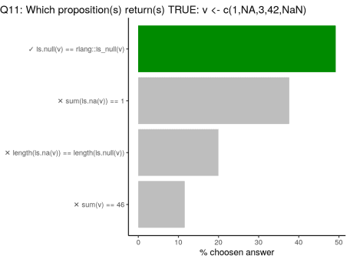

**Code of the question**

v <- c(1, NA, 3, 42, NaN)

# rlang::is_null is a wrapper around is.null

is.null(v) == rlang::is_null(v)

## [1] TRUE

# NA and NaN return TRUE with is.na()

sum(is.na(v)) == 1

## [1] FALSE

# is.na is vectorised and tests each value of `v`

# is.null tests the entire vector `v` and returns a unique value

length(is.na(v)) == length(is.null(v))

## [1] FALSE

# sum of values of a vector containing NA returns NA

# This tests returns NA

sum(v) == 46

## [1] NA

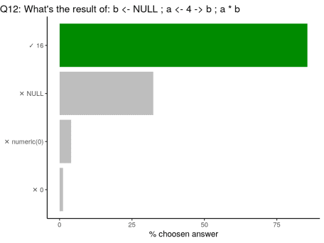

**Code of the question**

b <- NULL

a <- 4 -> b

a * b

## [1] 16

You can assign in both direction <- or ->. Thus, value of b is changed in the second line of code.

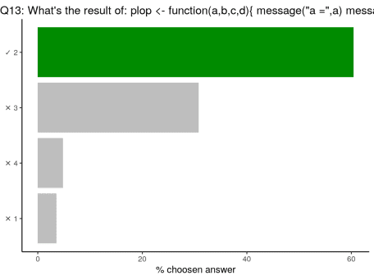

**Code of the question**

plop <- function(a, b, c, d) {

message("a =", a)

message("b =", b)

message("c =", c)

message("d =", d)

c

}

library(magrittr)

3 %>% plop(b = 1, 2, ., a = 4)

## [1] 2

In a function, parameters are attributed in the order, except when they are explicitely named. In this case, a and b are named. The two remaining are attributed in the order: c = 2 and d = . = 3 (thanks to the %>%). Function plop returns c, hence 2.

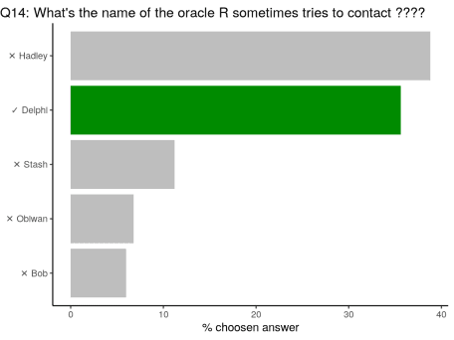

????plop

## Contacting Delphi...the oracle is unavailable.

## We apologize for any inconvenience.

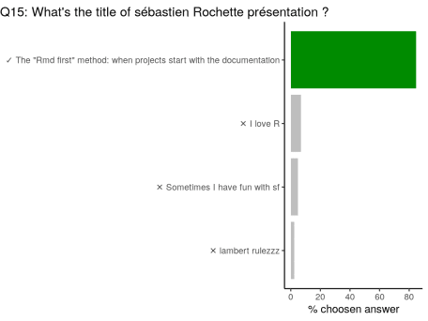

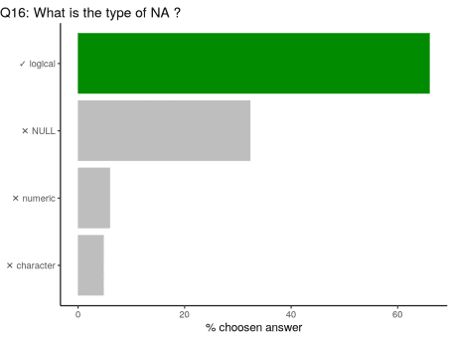

Type (or class) of NA is logical, like TRUE or FALSE. In some cases, you may want to use NA in another type, like when using if_else or case_when in {dplyr}. In this case, you can use NA_character_, NA_real_ or NA_integer_.

class(NA)

## [1] "logical"

class(NA_character_)

## [1] "character"

class(NA_real_)

## [1] "numeric"

class(NA_integer_)

## [1] "integer"

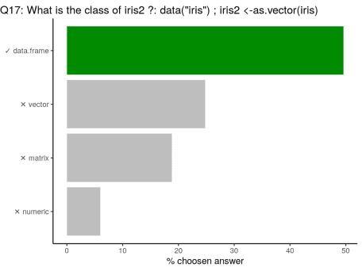

In R, everything is a vector. as.vector does not transform the object into a one-dimension object. In the case of a data.frame, you can use unlist to transform as a 1D object.

# Original iris

data("iris")

class(iris)

## [1] "data.frame"

dim(iris)

## [1] 150 5

# as.vector

iris2 <- as.vector(iris)

class(iris2)

## [1] "data.frame"

dim(iris2)

## [1] 150 5

# As 1D with unlist

iris3 <- unlist(iris)

class(iris3) # factors are transformed as numeric

## [1] "numeric"

dim(iris3)

## NULL

length(iris3)

## [1] 750

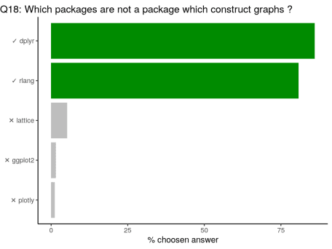

{dplyr} provides a flexible grammar of data manipulation. Thus no graphics.  
{rlang} provides tools to work with core language features of R and the tidyverse. Thus no graphics directly.  
{lattice}: The lattice add-on package is an implementation of Trellis graphics for R.  
{ggplot2} creates Elegant Data Visualisations Using the Grammar of Graphics.  
{plotly} creates Interactive Web Graphics via ‘plotly.js’

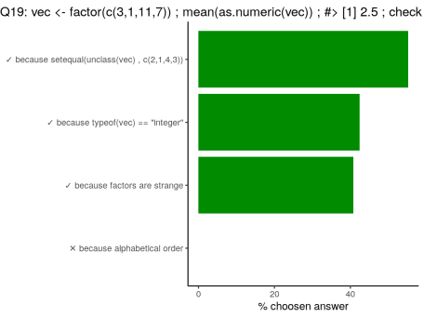

**Code of the question**

vec <- factor(c(3, 1, 11, 7))

mean(as.numeric(vec))

#> [1] 2.5

# check the reason(s) why ?

factors are a specific type in R. Factors are stored as integer reflecting the order of the objects, and levels, but the class is factor. unclass removes the class factor to get the stored type of objects (ranks as integer).

vec <- factor(c(3, 1, 11, 7))

vec

## [1] 3 1 11 7

## Levels: 1 3 7 11

# class

class(vec)

## [1] "factor"

# unclass

unclass(vec)

## [1] 2 1 4 3

## attr(,"levels")

## [1] "1" "3" "7" "11"

# test of unclass

setequal(unclass(vec), c(2, 1, 4, 3))

## [1] TRUE

# storage mode of the object

typeof(vec)

## [1] "integer"

# mean as none sense on factors

mean(vec)

## [1] NA

# as numeric, returns the ranks

as.numeric(vec)

## [1] 2 1 4 3

# answer is the mean of the ranks

mean(as.numeric(vec))

## [1] 2.5

# Let's see with letters?

vec2 <- factor(c("a", "b", "d", "c"))

class(vec2)

## [1] "factor"

typeof(vec2)

## [1] "integer"

mean(vec2)

## [1] NA

mean(as.numeric(vec2))

## [1] 2.5

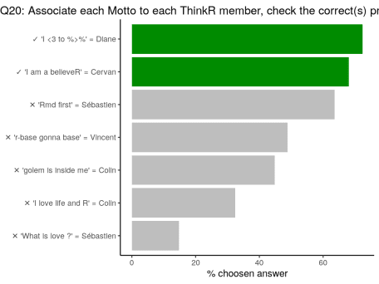



‘Rmd first’ could have been my motto, considering the title of my useR!2019 presentation, but the one embroidered on my T-shirt was “I *knight* with {rmarkdown}”. For the other mottos, I let you find out…

